# JOBSHEET W06

**INHERITANCE**

# COMPETENCE

* 1. Understand the basic concept of inheritance.
  2. Able to create a subclass of a certain superclass.
  3. Able to implement the concept of hierarchical inheritance
  4. Able to create objects from a subclass and access attributes and methods either own or derived from their superclass.

# INTRODUCTION

**Inheritance** in object oriented programming is the concept of **inheritance** from a more general class to a more specific class. The class that is derived is called the base class ( **base class**/**super class/parent class**), while the class that is derived is called a derived **class** (**sub class**/**child class**). Each **subclass** will "inherit" the attributes and methods of the public *or* protected *superclass*. The benefit of inheritance is *reusability* or reuse of lines of code.

In the Java programming language, inheritance declarations are made by adding the **extends keyword** after the class name declaration, followed by the parent class-‐name. The extends keyword tells the Java compiler that we want to do **an extension/extension** of the class. Here is an example of an inheritance declaration.

public class B extends A {

...

}

The example above tells the Java compiler that class B is extending class A. This means that class B is a subclass of class A by extension. This extension will be done by adding special attributes and methods that only class B has.

A parent class can limit the attributes and methods that will be inherited to its subclasses . The restriction is carried out through the determination of access level modifiers. In Java, the access level modifier attributes and methods are summarized in the following table:

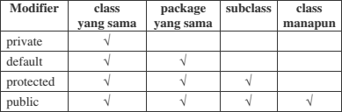

Attributes and methods that will be inherited from parent class to child class are attributes and methods with a protected or public modifier.

The keyword **this** is used to refer to the current object/class. While the **super** keyword is used to refer to the parent object/class. The writing format is as follows:

### super.<nameAttributes>

Accessing parent attributes

### super.<nameMethod>()

Calling the parent method

1. **EXPERIMENT 1 (extends)**
   1. **TRIAL STAGES**
      1. Create a parent class with the name of the Pegawai. Then create a parameterless constructor with the following line of code:

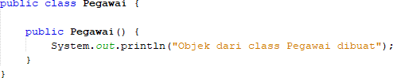

* + 1. Create a subclass of the Pegawai class with the name Dosen, then also create a parameterless constructor with the following line of code:

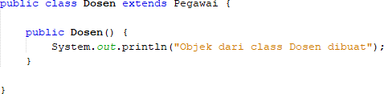

* + 1. Create a main class, for example InheritanceDemo.java, instantiate a new object named dosen1 from the lecturer class as follows:



* + 1. Run the program and then observe the results.
  1. **QUESTION**
     1. In experiment 1 above, determine the child class and parent class!
     2. What keywords make the child class and parent class have a relationship?
     3. Based on the results displayed by the program, how many constructors are executed? Which constructor class is executed first?

# EXPERIMENT 2 (Inheritance)

## TRIAL STAGES

* + - * 1. Add the nip, nama, and gaji attributes and the getInfo() method to the Pegawai class

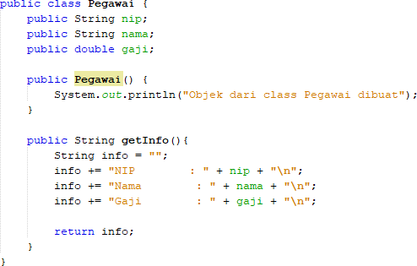

* + - * 1. Also add the NIDN attribute to the Dosen class

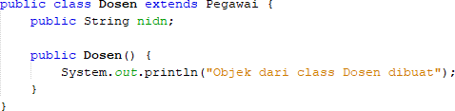

* + - * 1. In class InheritanceDemo.java write the following line of code:

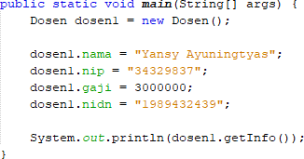

* + - * 1. Run the program then observe the results

## QUESTION

* + - * 1. In experiment 2 above, can the program run successfully or does an error occur?
        2. If the program is successfully executed, why is there no error in the assignment/filling in the values of the nip, gaji, and NIDN attributes on the lecturer object1 even though there is no declaration of these three attributes in the lecturer class?
        3. If the program is successfully executed, why is there no error in the call of the getInfo() method by the lecturer1 object even though there is no getInfo() method declaration in the dosen class?

# EXPERIMENT 3 (Access rights)

## TRIAL STAGES

* + 1. Modification of access level modifier on gaji attributes to private in class Pegawai.java

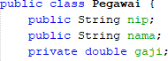

* + 1. Run the program then observe the results.
    2. Change the access level modifier of the gaji attribute to protected and then move the Pegawai class to a new package, for example "testpackage".

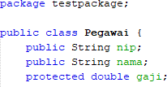

* + 1. Import the Pegawai class from the testpackage in the Dosen class.



* + 1. Access salary attributes in the Dosen class by trying to print the gaji attributes in the Lecturer constructor



* + 1. Change the access level modifier back to public and revert the Pegawai class to the original package.

## QUESTION

* + 1. In step 1 above, an error occurred because the dosen object1 could not access the gaji attributes. Even though gaji is an attribute of an pegawai who is the parent class of the dosen. Why does this happen?
    2. In step 5, after the Pegawai class moves to a different package, the Dosen class can still access the gaji attributes. Why?
    3. Based on the experiment, how to determine the attributes and methods that will be inherited by the parent class to the child class?

# EXPERIMENT 4 (Super - attributes)

## TRIAL STAGES

* + 1. Use the getAllInfo() method in the Dosen class

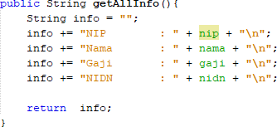

* + 1. Call the getAllInfo() method by the dosen1 object on class InheritanceDemo.java

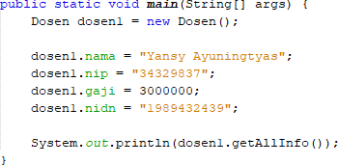

* + 1. Run the program then observe the results
    2. Modify the getAllInfo() method in the Dosen class

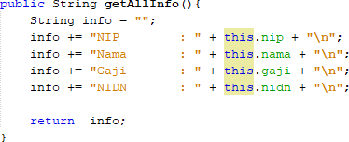

* + 1. Run the program then compare the results with step no 2.
    2. Modify the getAllInfo() method on the Dosen class again

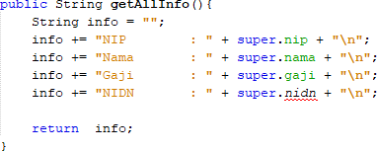

* + 1. Run the program and then compare the results with the program at no 1 and no 4.
    2. Modify the getAllInfo() method on the Dosen class again

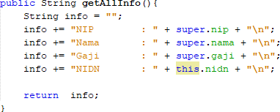

* + 1. Run the program and then compare the results with the program at number 2 and number 4.

## QUESTION

* + 1. Are there any differences in the results of nama, nip, and gaji displayed in programs 1, 4, and 8? Why?
    2. Why does the error occur in program no 6?

# EXPERIMENT 5 (super & overriding)

## TRIAL STAGES

* + 1. Modify the getAllInfo() method again. Run the program then observe the results

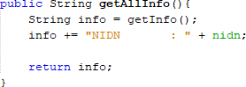

* + 1. Modify the getAllInfo() method again. Run the program then observe the results

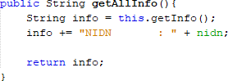

* + 1. Modify the getAllInfo() method again. Run the program then observe the results

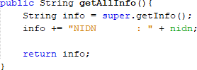

* + 1. Add the getInfo() method to the Dosen class and modify the getAllInfo() method as follows

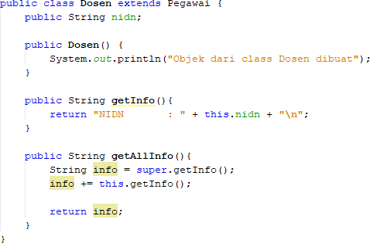

## QUESTION

* + 1. Are there any differences in the getInfo() methods accessed in steps 1, 2, and 3?
    2. Is there a difference between the super.getInfo() and this.getInfo() methods called in the getAllInfo() method in step 4? Explain!
    3. In what method does overriding occur? Explain!

# EXPERIMENT 6 (overloading)

## TRIAL STAGES

* + 1. Add a new constructor for the Dosen class as follows



* + 1. Modify the InheritanceDemo class to instantiate a new object with the name lecturer2 with a parameterized constructor. Run the program then observe the results.

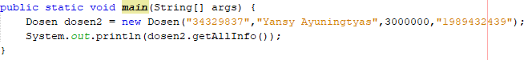

## QUESTION

* + 1. What are the results of the nip, nama, gaji, and nidn values displayed in step 2? Why is that?
    2. Explain whether the parameterless constructor and the Dosen class constructor created in step 1 have the same signature?
    3. What is the concept in OOP that allows a class to have a constructor or method with the same name and a different signature on a class?

# EXPERIMENT 7 (super-constructor)

## TRIAL STAGES

* + 1. Constructor modifications in the Dosen class are as follows. Run the program then observe the results.

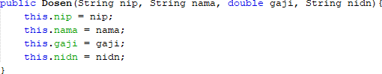

* + 1. Constructor modifications in the Dosen class are as follows. Run the program then observe the results.

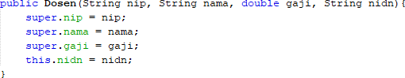

* + 1. Constructor modifications in the Dosen class are as follows. Run the program then observe the results.

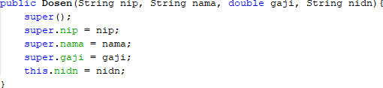

* + 1. Remove/comment constructor without parameters from the Pegawai class. Add a new constructor for the Pegawai class as follows. Run the program then observe the results.

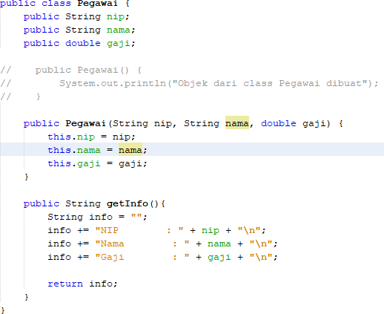

* + 1. Constructor modifications in the Dosen class are as follows. Run the program then observe the results.

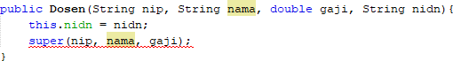

* + 1. Constructor modifications in the Dosen class are as follows. Run the program then observe the results.



## QUESTION

* + 1. Is there a difference in the results in steps 1 and 2? Explain!
    2. Is there a difference in the results in steps 2 and 3? Explain!
    3. Why did the error occur in step 4?
    4. What is the difference between super() called in steps 3 and 6?
    5. Why did the error occur in step 5?

# ASSIGNMENT

* 1. Define a class that is a derivative of another class.
  2. Create 3 attributes in the parent class then add at least 1 attribute in the child class.
  3. Perform the overloading method by creating 2 constructors, namely a parameterless

constructor and a parameterized constructor for each class. Call the parameterized super() constructor to create an object from the parent class on the child class constructor.

* 1. Implement the class diagram made in the theoretical PBO course
  2. Create a Demo class then instantiate the child class object in the main function
  3. Try modifying the attribute values (both those declared in the child class and those inherited from the print info.

### --- happy working----